EC axial fan in cooling tower

Product Introduction

These series EC axial fans are specially designed for wet cooling tower, air cooled heat exchangers, air-cooled condensers (ACC) to replace normal fans by one speed output with AC inverter or belt transmission.
This EC motor direct driven axial fans offer big air flow and medium pressure to exhaust the moisture air from the fills in cooling tower
Permanent magnet brushless EC motor with integrated inverter offers high efficiency, variable speed control to suit for various heat load with ambient temperature change
High protection grade at IP65 will be avoid moisture ingress into the motor
Robust design in aluminum blades, or PP blades as per airflow and pressure requirements
Power cables and control cables are lead separately for easy connection on sites
Continuously variable speed settings by 0-10VDC/PWM interface or MODBUS RTU. We will provide RS485 communication protocol free of charge
Installation type can be horizontal or vertical as per request.
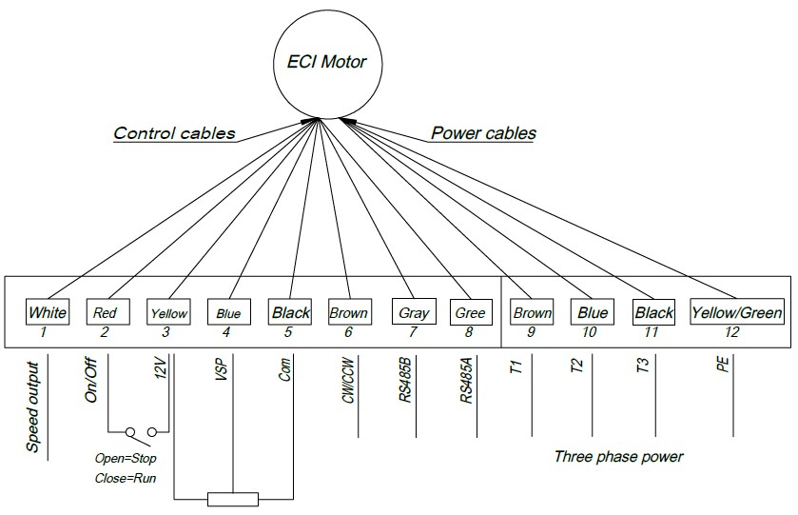
Wiring of the EC motor

Product advantage

Increasing efficiency of cooling tower by logic control

Fans are the most important parts of the cooling tower in efficiency. As we know, the heat load of cooling tower is different, while the ambient temperature for cooling towers is also different due to the different time of days and seasons. Fixed speed AC fans only can control airflow by motors ON/OFF. The power saving difference can be found by below curve
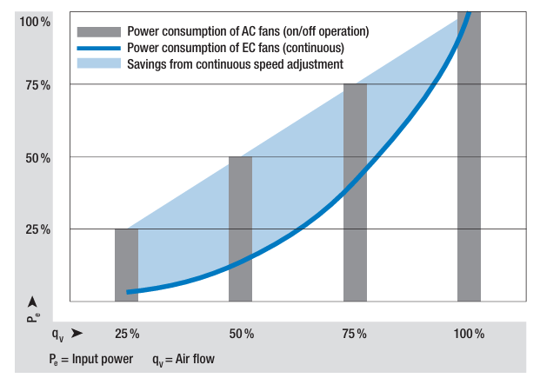
Performance curve

Why can EC motors and EC fans offer high efficiency?
The power consumption of EC motors is related to its speeds. the below formula can explain one of route reason
As per actual heat load, it is possible to change the fan speed to regulate the fan airflow. At same time, the EC fan speed and EC motor power consumption will be changed also to save more energy. By this way, the EC motor is also in less load running to extend lifespan.

Technical Parameters
Fan model | Dia | Air Flow | Static Pressure | Q | Ps | Pt | n | Shaft power | Input Power | Full load Amps | Noise Level(3m)
Fan model | mm | CFM | mmWG | m^3/h | Pa | Pa | RPM | kW | kW | A | dB(A）
DWCT10H-EC | 1000 | 15200 | 2.5 | 25825 | 25 | 75 | 635 | 1.11 | 1.23 | 3.4 | 60
DWCT10H-EC | 1000 | 11800 | 2.5 | 20048 | 25 | 55 | 510 | 0.71 | 0.81 | 3.4 | 55
DWCT10H-EC | 1000 | 18400 | 2.5 | 31262 | 25 | 98 | 760 | 1.9 | 2.13 | 3.4 | 64
DWCT10H-EC | 1000 | 12700 | 2.5 | 21577 | 25 | 59 | 540 | 0.82 | 0.92 | 3.4 | 56
DWCT12.5H-EC | 1250 | 17980 | 2.5 | 30548 | 25 | 53 | 400 | 0.95 | 1.13 | 3.4 | 56
DWCT12.5H-EC | 1250 | 14500 | 2.5 | 24636 | 25 | 43 | 335 | 0.65 | 0.77 | 3.4 | 53
DWCT12.5H-EC | 1250 | 21460 | 2.5 | 36461 | 25 | 65 | 465 | 1.53 | 1.78 | 3.4 | 60
DWCT12.5H-EC | 1250 | 15370 | 2.5 | 26114 | 25 | 45 | 352 | 0.72 | 0.85 | 3.4 | 54
DWCT8H-EC | 800 | 9800 | 2.5 | 16650 | 25 | 75 | 800 | 0.72 | 0.83 | 3.3 | 56
DWCT8H-EC | 800 | 6400 | 2.5 | 10874 | 25 | 46 | 550 | 0.32 | 0.38 | 3.3 | 50
DWCT8H-EC | 800 | 10600 | 2.5 | 18010 | 25 | 84 | 850 | 0.86 | 0.99 | 3.3 | 58
DWCT8H-EC | 800 | 7700 | 2.5 | 13082 | 25 | 56 | 640 | 0.45 | 0.52 | 3.3 | 52

Product uses
EC (Electronically Commutated) motors are permanent magnet motors which are running on high voltage direct current (DC) electricity with built in AC to DC conversion allowing them to run direct from single phase or three phase mains supplies. They are more efficient, quieter and more reliable compared to AC motors.
We have revolutionized the control of the fan in cooling tower industry by integrating the EC motors technology in the new series of cooling tower which is the open type mechanical induced cooling tower driven by EC Motors.
The EC motors have built in starter, controller, motor protection and EMI filters. It will directly drive the high efficient impeller with speed control and inputs from sensors for water temperature and ambient temperature for control & monitoring capacity. The EC motors will be directly connected to computer with minimum set up as ‘plug and play’ concept. This will eliminate the need of using Motor Starters and Programmable Logic Controller (PLC) or Variable Frequency Drive

Product operation guide

Product video
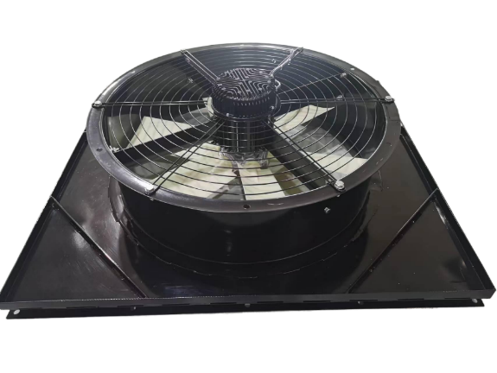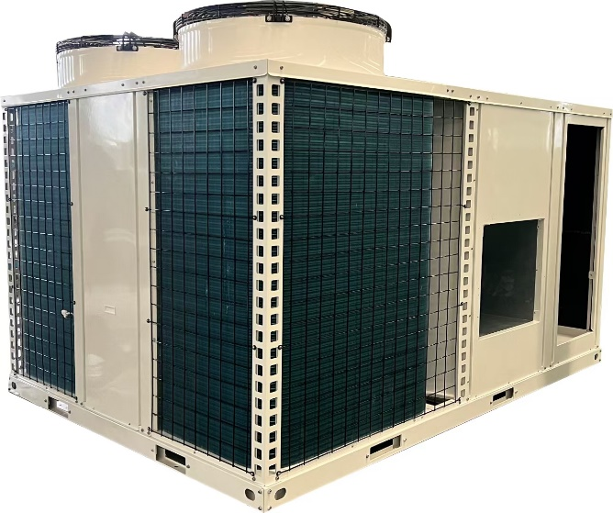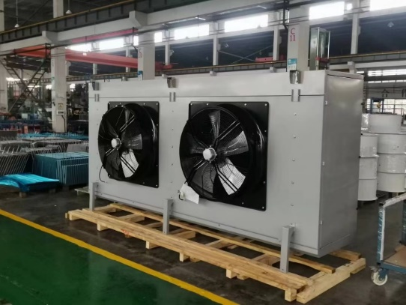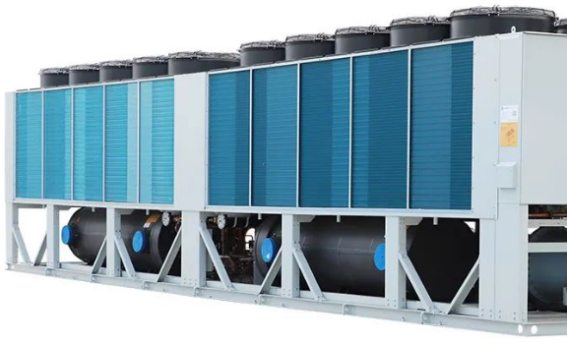

FAQ

